

Health Benefits Update  
Form 10-10EZ (Digitization)

Version 2  
Version Date: July, 2024

Launch: April 11, 2024

Table of Contents

Overview and Navigation

Introduction Page

Signed-in Users: LOA1 (Not Identity Verified)

Signed-in Users: LOA3 (Identity Verified)

Filling Out the Form

Veteran Information

Step 1 of 5: Names  
 Authenticated User

Step 1 of 5: Mailing Address

Step 1 of 5: Phone and Email

Military Service

Step 2 of 5:

Step 2 of 5: Marital Status

Step 2 of 5: Marital Status

Step 2 of 5: Marital Status

Step 2 of 5: Marital Status

Household Information

Step 3 of 5: Marital Status

Step 3 of 5: Spouse’s Personal Information

Step 3 of 5: Spouse’s Additional Information

Step 3 of 5: Spouse’s Financial Support

Step 3 of 5: Dependent’s Information

Step 3 of 5: Dependent’s Personal Information

Step 3 of 5: Dependent’s Education Expenses

Step 3 of 5: Dependent’s Additional Information

Step 3 of 5: Dependent’s Annual Income (Previous Year)

Review Your Dependents

Step 3 of 5: Annual Income

Step 3 of 5: Previous Calendar Year Deductible Expenses

Insurance Information

Step 4 of 5: Medicaid

Step 4 of 5: Medicare

Step 4 of 5: Medicare Detail

Step 4 of 5: Other Coverage

Step 5 of 5: Review

Health Benefits Update Form Troubleshooting

Questions About the Content of the Form

Form is Pre-filled With Incorrect Information

Veteran Can’t Move Forward in Their Form

Veteran is Having Trouble Upgrading From LOA1 to LOA3

# Overview and Navigation

VA.gov users can update their health care benefits information by filling out the online VA Form 10-10EZR, the Health Benefits Updates Form. Users with an LOA1 account (not identity verified), or an LOA3 account (identity verified) can access and complete the Health Benefits Update Form.

A user can find the Health Benefits Update Form at <https://www.va.gov/health-care/update-health-information> or the following VA.gov locations:

* On the VA.gov VA health care page: [www.va.gov](http://www.va.gov/)/health-care

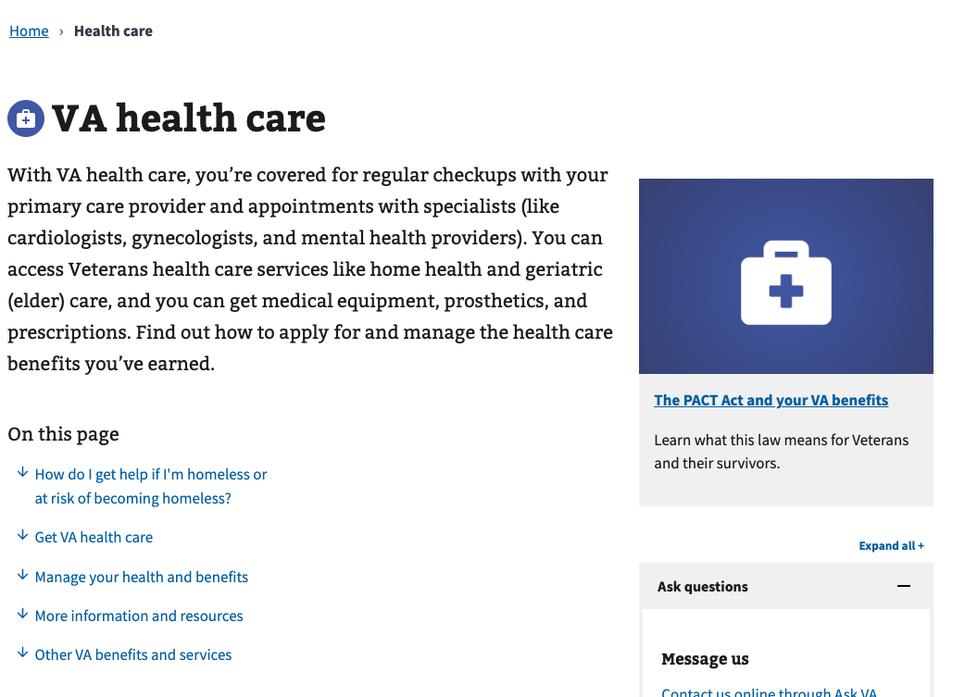

* In the VA health care benefit hub: <https://www.va.gov/health-care/>

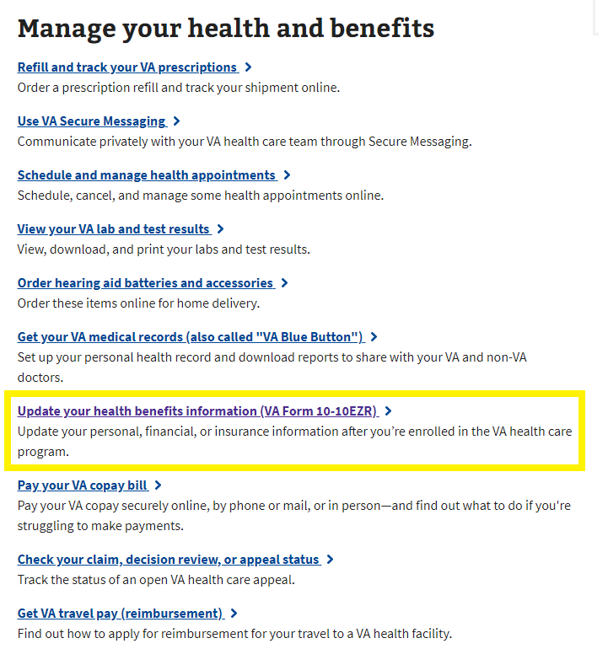

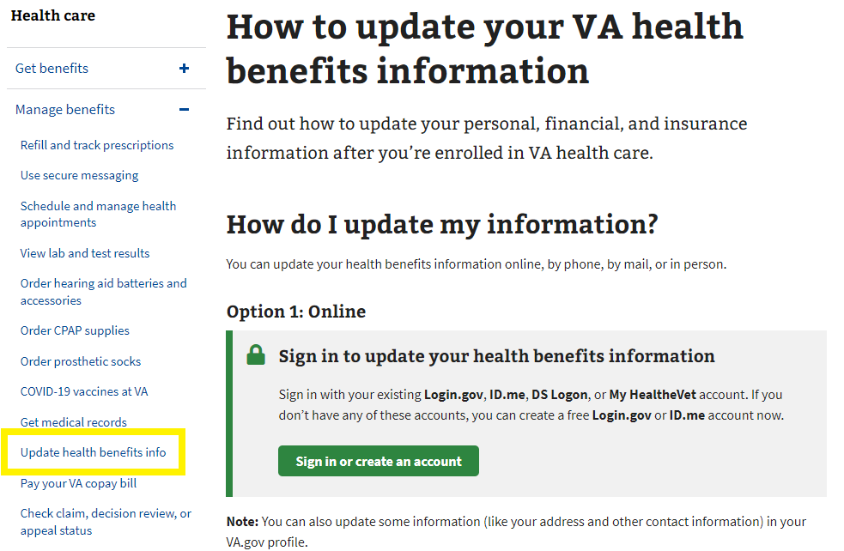

* In the My HealtheVet hub: <https://www.va.gov/my-health/>

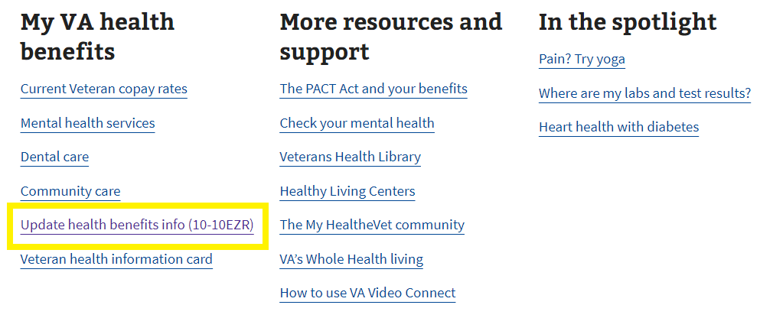

# Introduction Page

Currently, the Update Health Benefits form is available on VA.gov (https://www.va.gov/my-health/update-benefits-information-form-10-10ezr/introduction) to signed-in users who come to the site and are enrolled in VA health care, whether they are LOA1 or LOA3.

Unauthenticated users will be prompted to sign in to update their information online.

## 

## Signed-in Users: LOA1 (Not Identity Verified)

Signed-in LOA1 users will see the following alert when they go to the Health Benefits Update Form introduction page at <https://www.va.gov/my-health/update-benefits-information-form-10-10ezr/introduction>. LOA1 users won’t be able to access the Health Benefits Update Form without first verifying their identity and becoming LOA3. This identification process makes sure that all users who apply are scanned through the ESR to verify whether they are enrolled in VA health care.

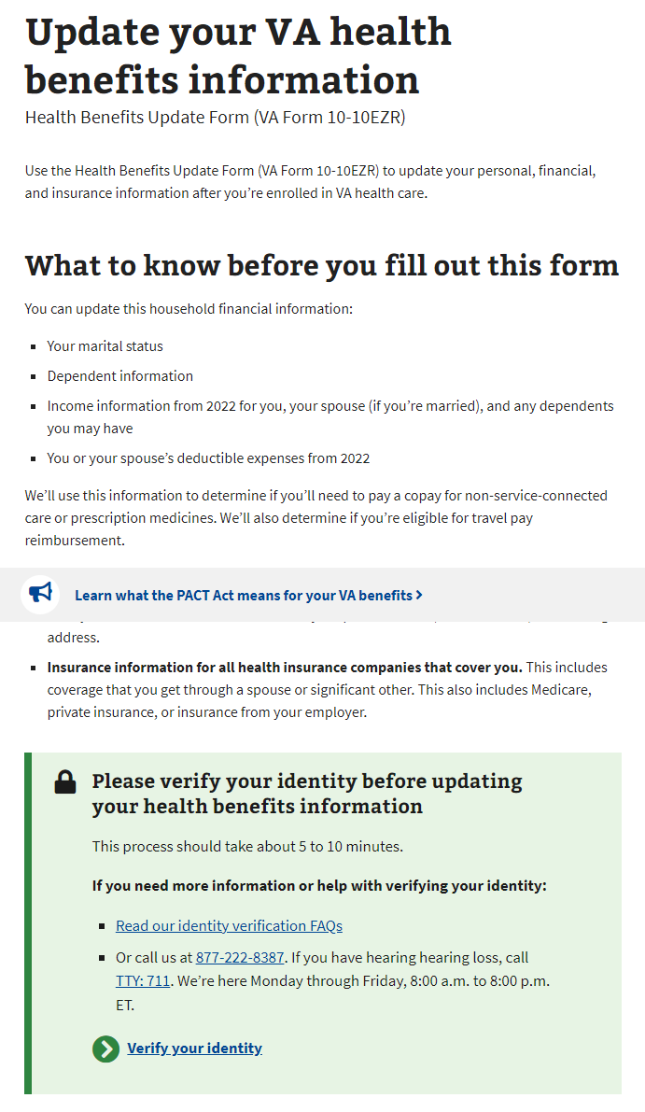

## Signed-in Users: LOA3 (Identity Verified)

For signed-in LOA3 users, we will automatically perform a scan on the backend for existing health care records in the enrollment system (ESR) when they go to the form introduction page at https://www.va.gov/my-health/update-benefits-information-form-10-10ezr/introduction

For users not found in the ESR, they will not be able to go straight into the Health Benefits Update Form, and instead will see a message advising them to apply for health care with a link to the Veteran health care application (10-10EZ):

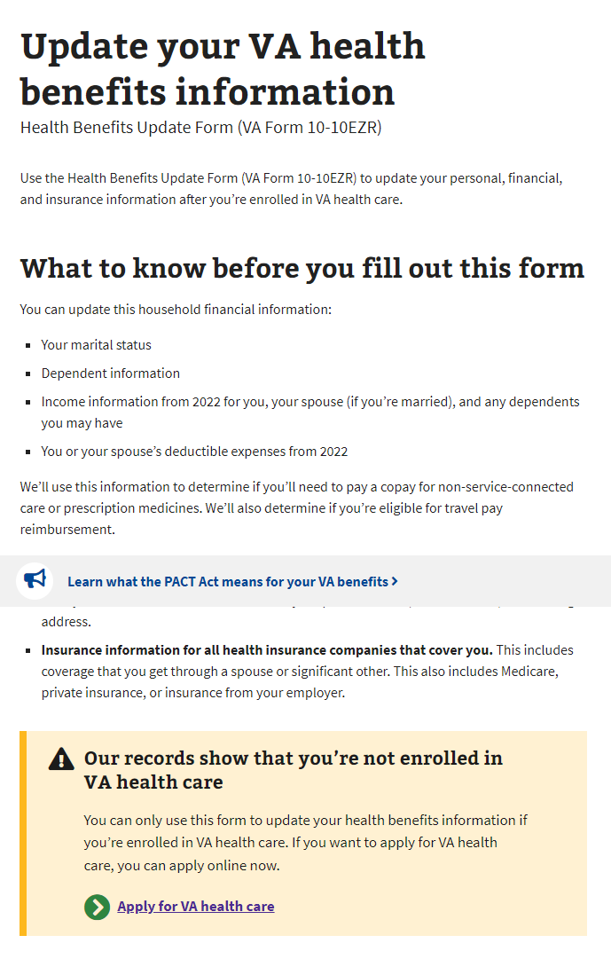

For users found in the ESR, they will fill out the Health Benefits Update Form.

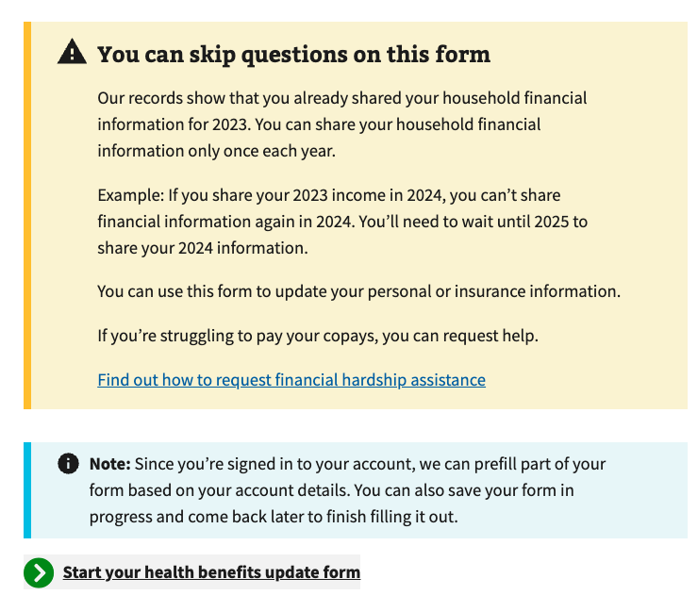

# Filling Out the Form

There are 5 sections in the Health Benefits Update Form:

1. Veteran information
2. Military Information (including Toxic Exposure)

Household information

1. Insurance information
2. Form review

Please note: The system will prefill some of the information we already have on file. The user can review and update some of this information as they complete the form.

Each section has multiple pages of questions that the user must enter to complete the form. The form automatically saves as the user progresses and they can “Finish this form later” if they choose.

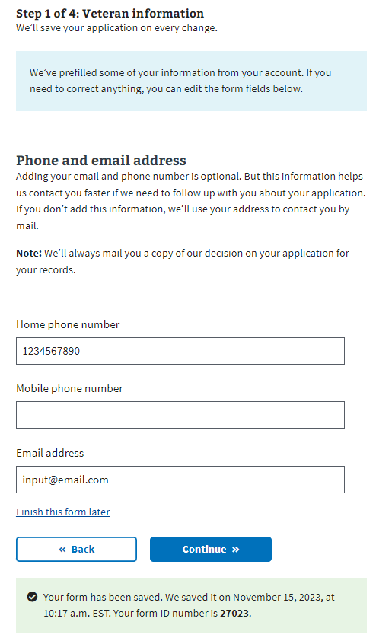

To move forward through the form, the user clicks “Continue.” They cannot move forward until all required information on the page is complete. An example error message is shown below. To go back to a section of the form, the user can use the back button.

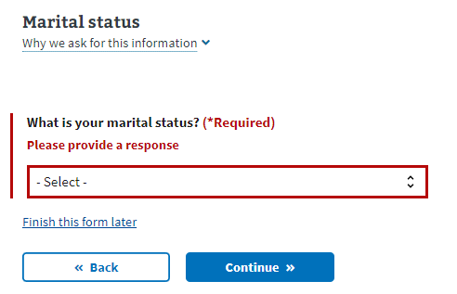

The form also has a status bar at the top of each page to indicate how far along in the form a Veteran is. It progresses when a new section is complete, not based on the number of questions completed:

## 

## Veteran Information

### Step 1 of 5: Names

Users are shown their name, DOB, and Social Security number in a locked state. If they need to update this information, they must contact the VA Benefits Hotline at 1-800-827-1000.

Authenticated User

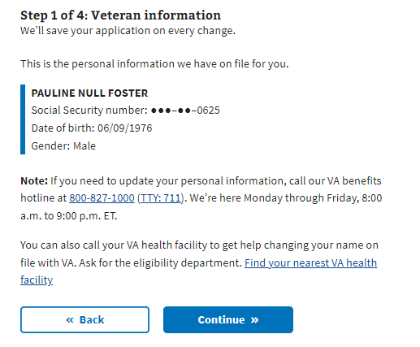

### Step 1 of 5: Mailing Address

If the user indicates that their mailing address is different from their home address, they must enter their home address on the following page.

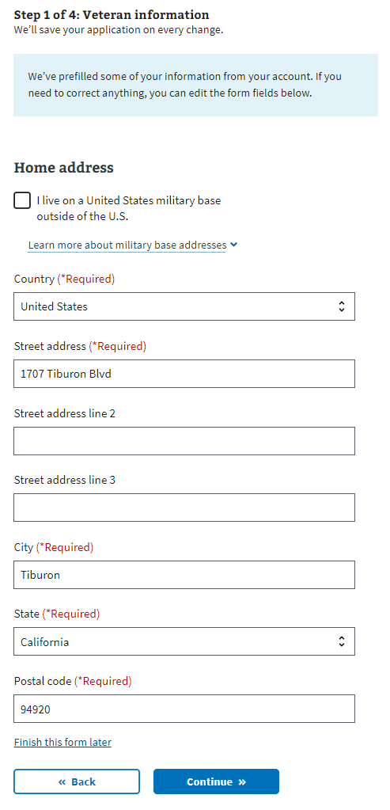

### Step 1 of 5: Phone and Email

Users may provide their email address and home/mobile telephone numbers. If the user decides to share this information, VA will use these to communicate with the Veteran during the form process. If they do not provide either, correspondence is sent via postal mail.

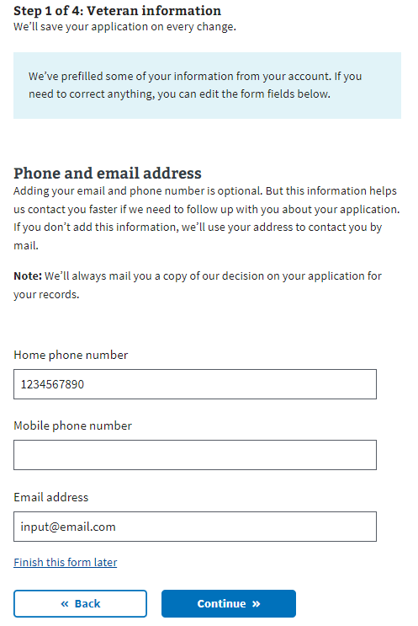

## Military Information

### 

### Step 2 of 5: Military Service

Military Service: Page 1

This page is to explain about toxic exposure and provide resources a user might want to access to learn more. A user can choose whether or not to answer questions regarding military service history and any toxic exposure (or potential toxic exposure). The questions that follow will be asking about specific locations, operations, and toxins where the Veteran may have been exposed.

## 

### Military service page 2: Cleanup or response efforts

A user can indicate whether they participated in any of the cleanup or response efforts listed on this page.

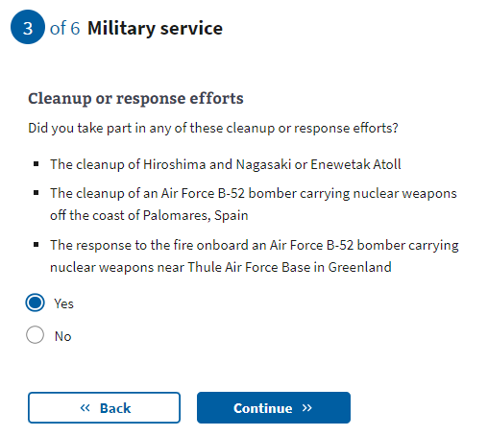

[Military service page 3: Service in Gulf War locations](https://docs.google.com/document/d/1q11ictK4zNJR4xZSBCcdndDI_PTItqzqFKfw8N3c1cA/edit?pli=1#bookmark=id.19c6y18)

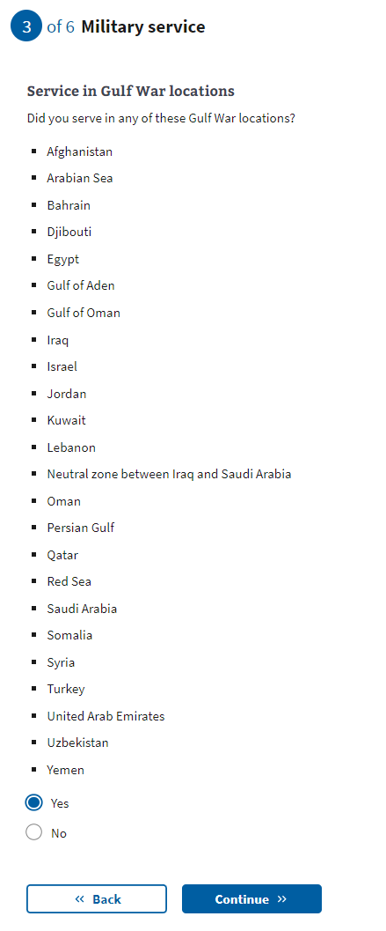

[Military service page 4:](https://docs.google.com/document/d/1q11ictK4zNJR4xZSBCcdndDI_PTItqzqFKfw8N3c1cA/edit?pli=1#bookmark=id.19c6y18) Service dates for Gulf War locations

These date fields are optional. A user can provide a month and year, or a date range if they know this information. If the user does not know or does not want to estimate a date or range, they can leave these optional fields blank and continue to the next page.

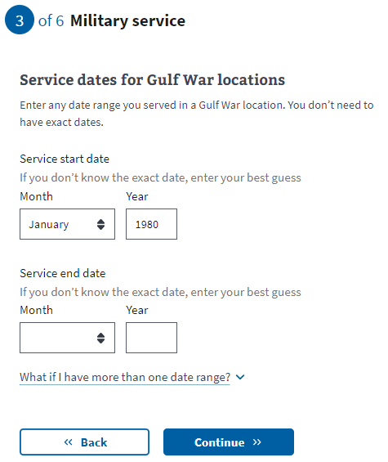

[Military service page 5:](https://docs.google.com/document/d/1q11ictK4zNJR4xZSBCcdndDI_PTItqzqFKfw8N3c1cA/edit?pli=1#bookmark=id.19c6y18) Operations

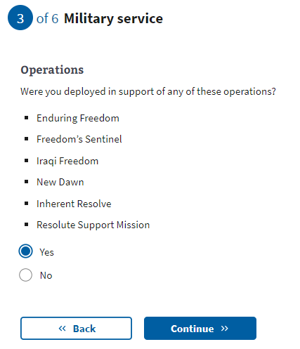

[Military service page 6:](https://docs.google.com/document/d/1q11ictK4zNJR4xZSBCcdndDI_PTItqzqFKfw8N3c1cA/edit?pli=1#bookmark=id.19c6y18) Agent Orange locations

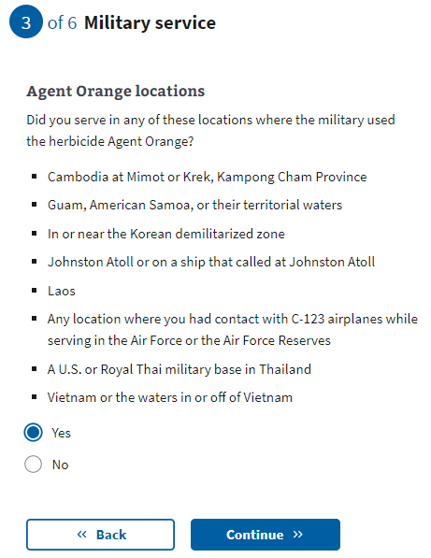

[Military service page 7:](https://docs.google.com/document/d/1q11ictK4zNJR4xZSBCcdndDI_PTItqzqFKfw8N3c1cA/edit?pli=1#bookmark=id.19c6y18) Other toxic exposures

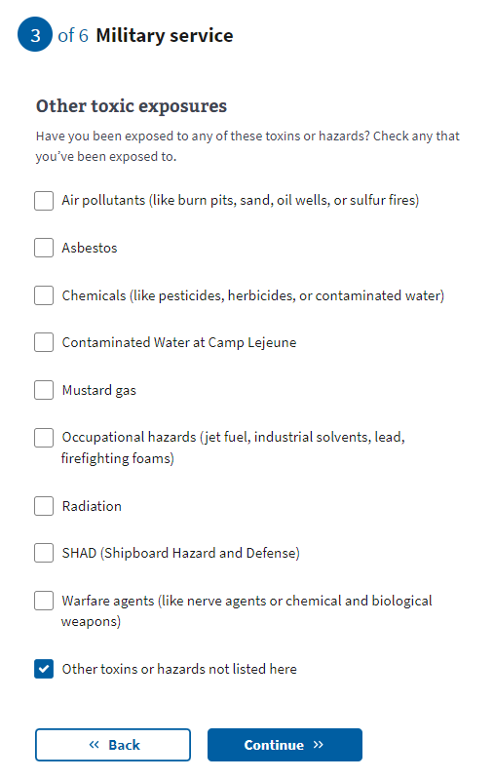

[Military service page 8: Other toxic](https://docs.google.com/document/d/1q11ictK4zNJR4xZSBCcdndDI_PTItqzqFKfw8N3c1cA/edit?pli=1#bookmark=id.19c6y18) exposure

If the user selects “Other toxins or hazards not listed here” from the previous question, they will be asked to list the toxin(s) that they may have experienced exposure.

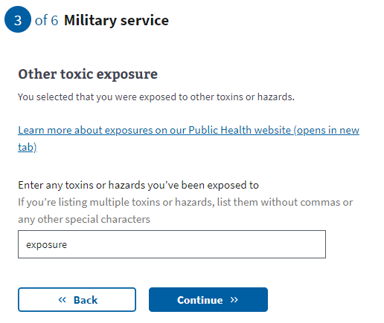

[Military service page 9: Dates of](https://docs.google.com/document/d/1q11ictK4zNJR4xZSBCcdndDI_PTItqzqFKfw8N3c1cA/edit?pli=1#bookmark=id.19c6y18) exposure

These date fields are optional. A user can provide a month and year, or a date range if they know this information. If the user does not know or does not want to estimate a date or range, they can leave these optional fields blank and continue to the next page.

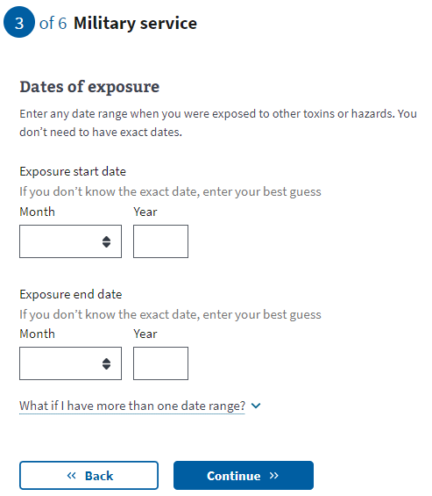

## Household Information

### 

### Step 3 of 5: Marital Status

The user will now need to indicate their marital status from the drop-down.

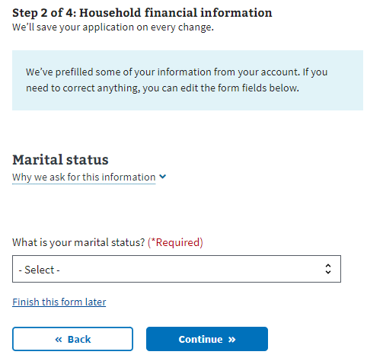

### Step 3 of 5: Spouse’s Personal Information

If the Veteran has indicated they are married or separated, they must fill out their spouse’s information.

If they have indicated that they have never married, are divorced, or widowed, they must complete the insurance information section next.

### 

### Step 3 of 5: Spouse’s Additional Information

The Veteran must specify whether their spouse lived with them during the previous year and whether they live with them now. This information will help determine whether the spouse should be considered a dependent.

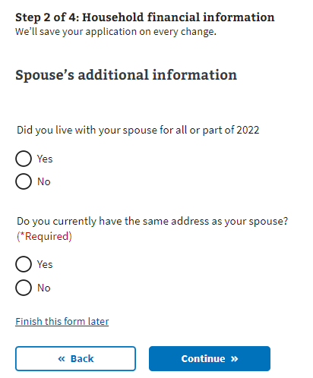

### Step 3 of 5: Spouse’s Financial Support

If the Veteran indicates that they did not live with their spouse in the previous year, they must specify whether they provided financial support to their spouse.

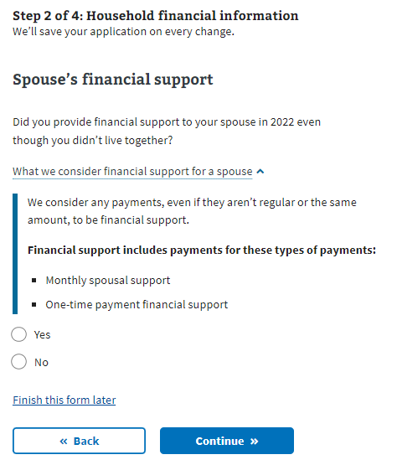

### Step 3 of 5: Dependent’s Information

If the Veteran wants to add their dependent, the form will ask them to input information about that person. They will have the option to enter more than one dependent.

Examples of when someone becomes your dependent:

* **Birth of a child**: The DOB would be the date the child became your dependent.
* **Adoption**: The official date of adoption would be the date on which the child became your dependent.

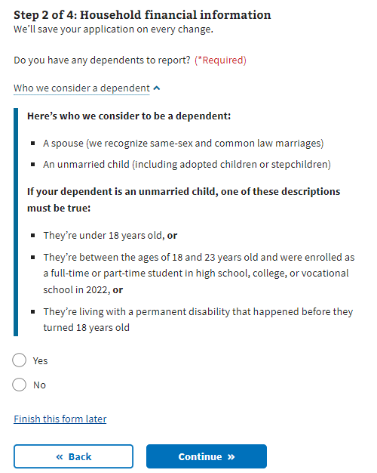

### Step 3 of 5: Dependent’s Personal Information The Veteran must provide the dependent’s information. All required fields must be completed before saving the form. If the Veteran exits before completing the necessary fields for the dependent, the form won’t save and they’ll have to re-enter the data.

### 

### Step 3 of 5: Dependent’s Education Expenses

If the dependent is between the ages of 18 and 23, the Veteran must provide education expenses information.

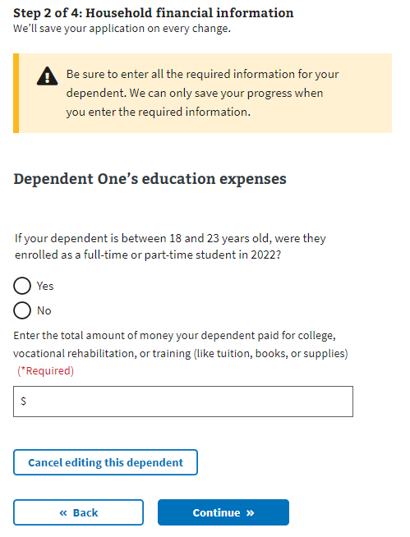

### Step 3 of 5: Dependent’s Additional Information

The Veteran must indicate whether their dependent was permanently disabled before turning 18 years old, whether they lived with them during the previous year, and if the dependent earned any income during the last year.

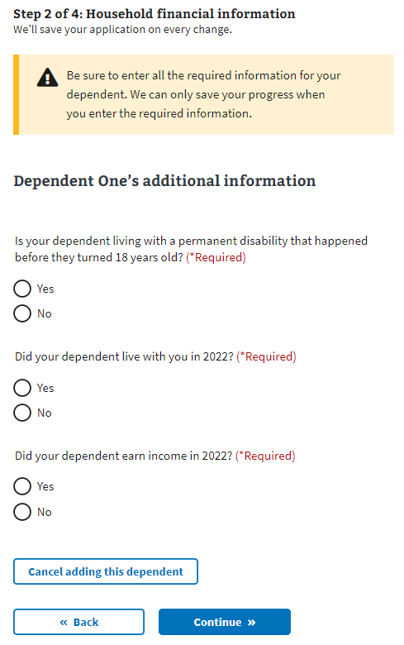

### Step 3 of 5: Dependent’s Annual Income (Previous Year)

If the Veteran indicates that their dependent earned income during the previous year, the form requires the income details.

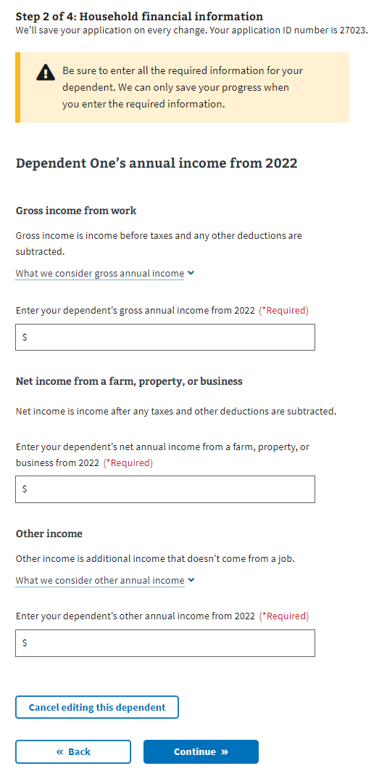

### Review Your Dependents

Once the user has entered at least one dependent, they will see their dependent listed and be able to edit or remove the information. The user can add additional dependents by answering “Yes” to the question “Do you have another dependent to report?”  
  
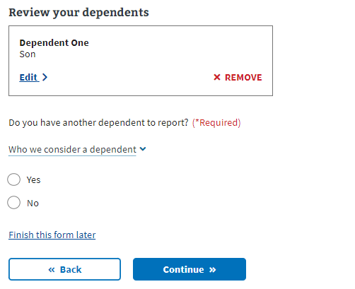

### Step 2 of 5: Annual Income

The user must provide the requested financial information in the following forms. The form will ask about their annual income and previous year’s deductible expenses. If the Veteran indicated they were married, they must also disclose their spouse’s annual income.

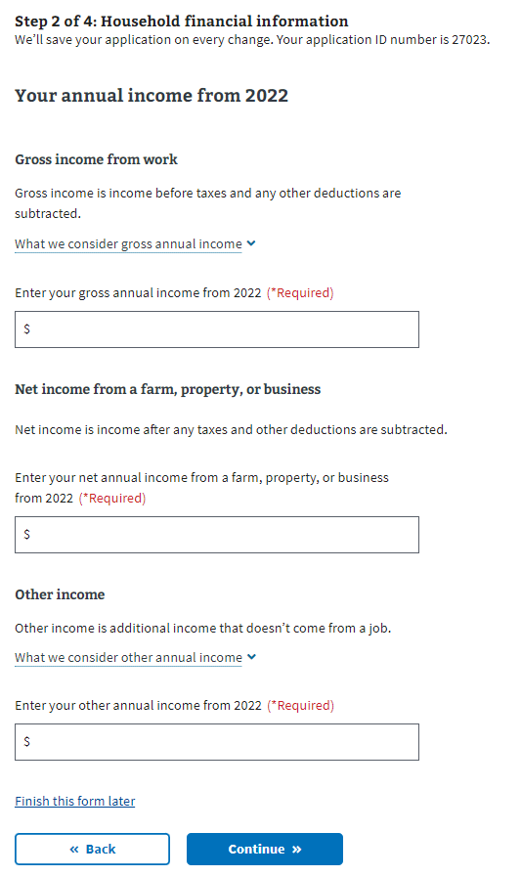

### Step 3 of 5: Previous Calendar Year’s Deductible Expenses

### 

## Insurance Information

### Step 4 of 5: Medicaid

All users view this page. The user needs to indicate whether they’re eligible for Medicaid.

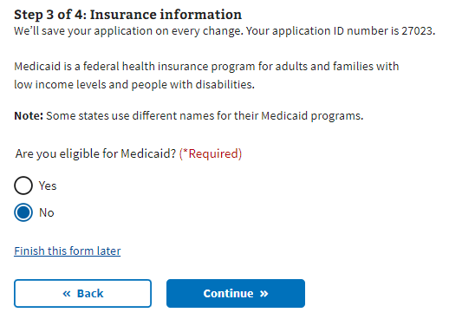

### Step 4 of 5: Medicare

If the user is enrolled in Medicare Part A, they must indicate so during this step. Selecting “Yes” sends the user to a page where they provide the effective date of their Medicare Part A coverage.

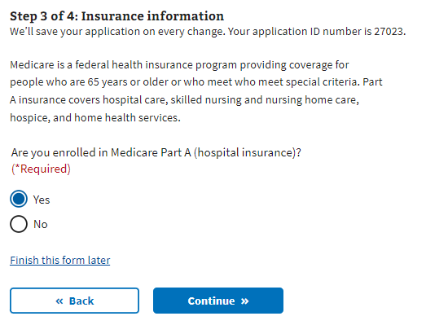

### 

### Step 4 of 5: Medicare Detail

The user is required to disclose the effective date of their Medicare Part A and Medicare claim number.  
  
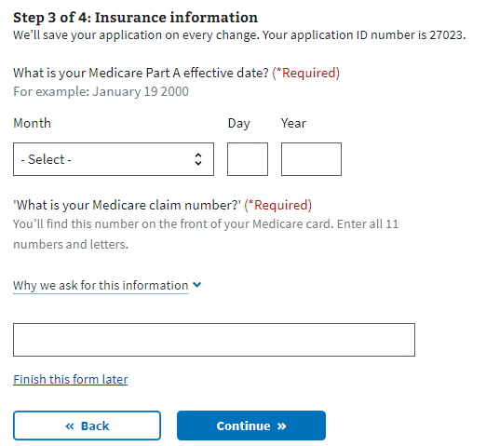

### Step 4 of 5: Other Coverage

The user needs to indicate whether they have any additional health insurance coverage. If they do, the user must select “Continue” to proceed to the next page and input that information.

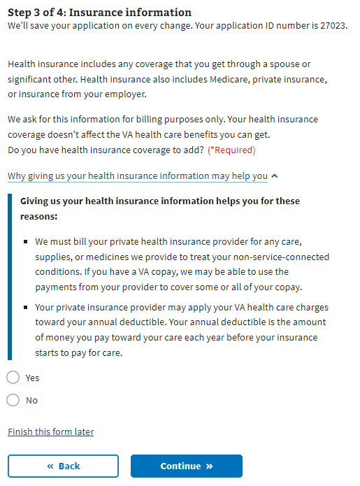

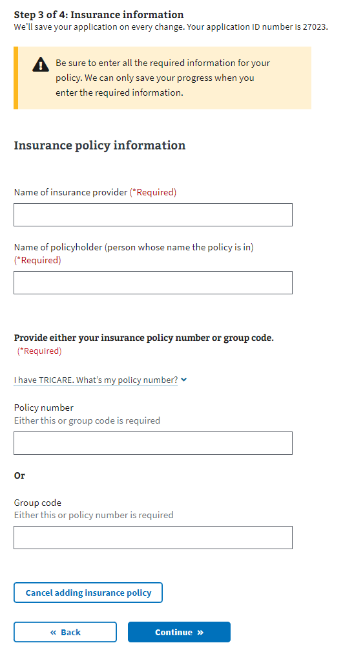

Once the user has entered at least one insurance policy, they will see their insurance policy listed and be able to edit or remove the information. They will have the option to enter more than one insurance policy.

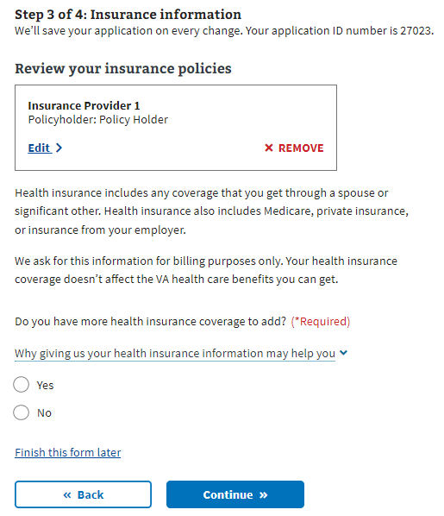

## Step 5 of 5: Review

Once the Veteran has completed the form, they see the Review step where they can open each section and see what information they entered.

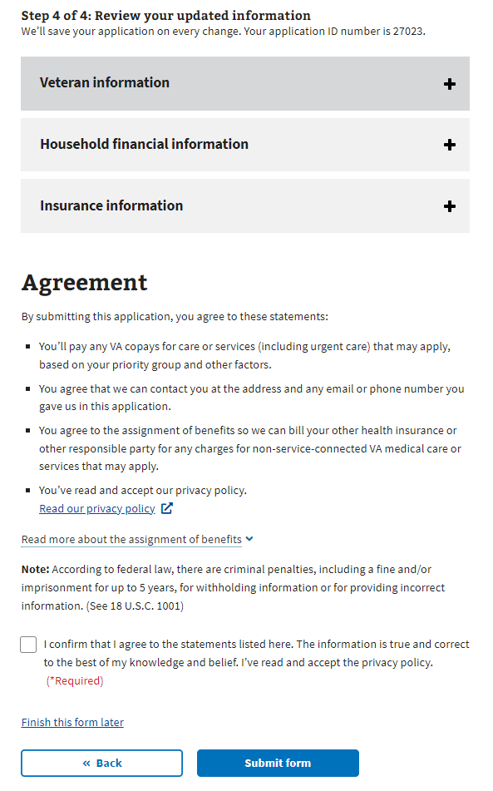

If they want to change the information shown, they can select the “Edit”button and make changes to that information.

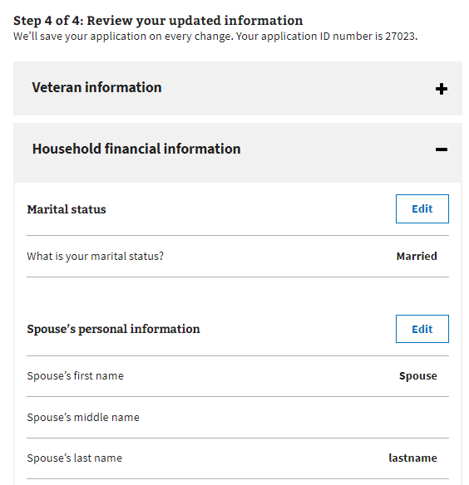

Once the user presses the “Edit” button, they can update their information if needed. They’ll need to make sure to press the “Update Page” button to save the changed information.

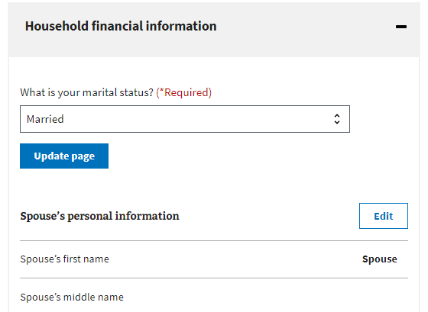

If any changes made remove required information or trigger additional questions, the form will draw the user’s attention to where updates are needed.

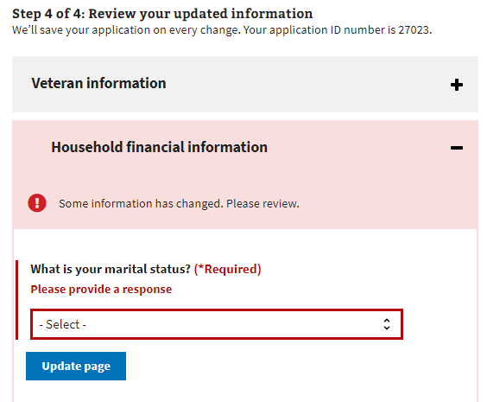

Once the user has reviewed the information and is ready to submit the form, they must select the check box indicating they agree to the statements listed, that the information is accurate and that they have read and accepted the privacy policy. The privacy policy is accessible via a provided link that leads to a new tab; their form won’t be interrupted.

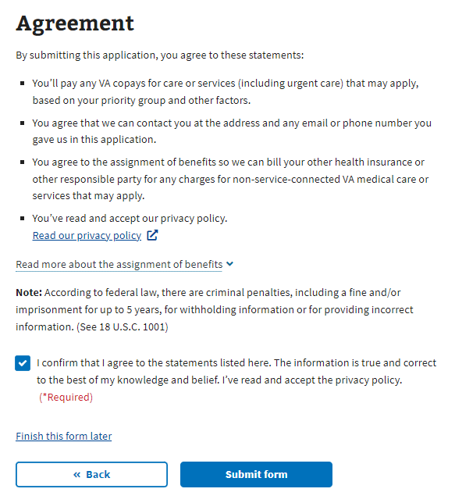

After form submission, the user sees the following information:

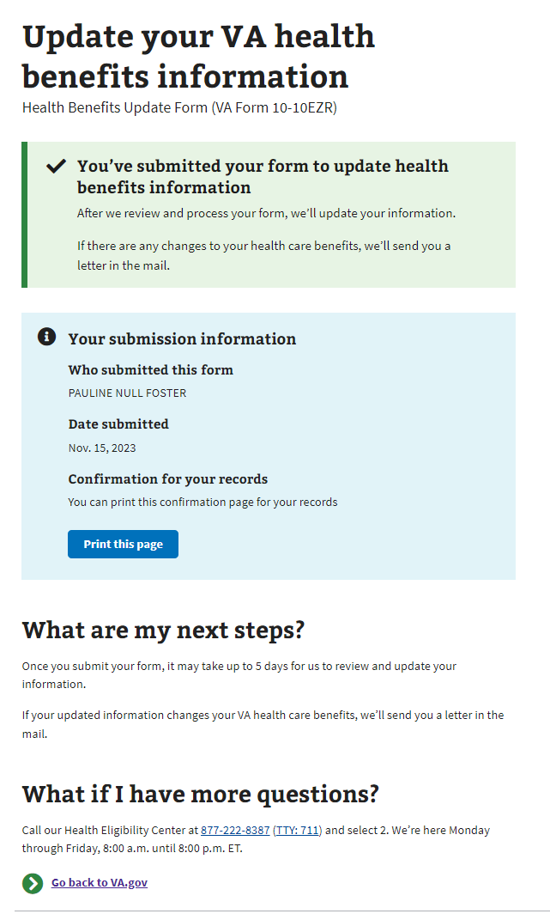

# Health Benefits Update Form Troubleshooting

## Questions About the Content of the Form

Many Veterans will have specific questions about the content of the form because they don’t understand what the form is asking or why it needs that information. These are non-technical issues of which the Health Enrollment Center (HEC) should be made aware. Before transferring the Veteran to this call center, make sure they don’t have any questions related to the navigation or issues entering information for technical reasons.

The information for the HEC is at the bottom of every page in the Health Benefits Update Form:

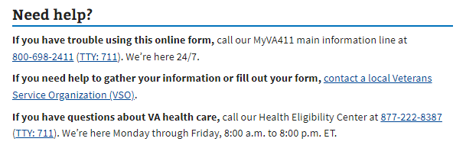

## Form is Prefilled With Incorrect Information

If a Veteran has already entered information about themselves or their account has personal, contact, or spouse information associated with it, that information should populate the form. The purpose is to make it easier for the Veteran to complete the form. However, if information is incorrect, it may confuse the Veteran. They can fix this by editing their information directly in the form.

## Veteran Can’t Move Forward in Their Form

If a Veteran is saying they can’t move on to the next page in the form, ask them to verify that they have filled out all the required information. The website will display red text indicating where necessary information is missing:  
  
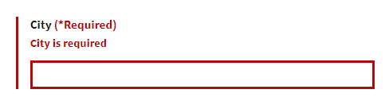

## Veteran is Having Trouble Upgrading From LOA1 to LOA3

If a Veteran is trying to apply for health care benefits with their LOA1 (not identity verified account), they will be required to upgrade to an LOA3 (identity verified) account. They can do this using ID.me, Login.gov, or an upgraded My HealtheVet or DS Logon account. If the Veteran prefers not to do this, they can update their information over the phone or in person at their local VA facility.